Assignment-1

Name: Shreyan Reddy Gangwar

ST ID:12599073

2) Visualization

A)This code creates a bar chart of the gender distribution in the dataset. The x-axis shows the 'Female' and 'Male' categories, and the y-axis shows the corresponding counts. The chart uses violet and blue bars to differentiate the genders, providing a clear image of gender distribution.

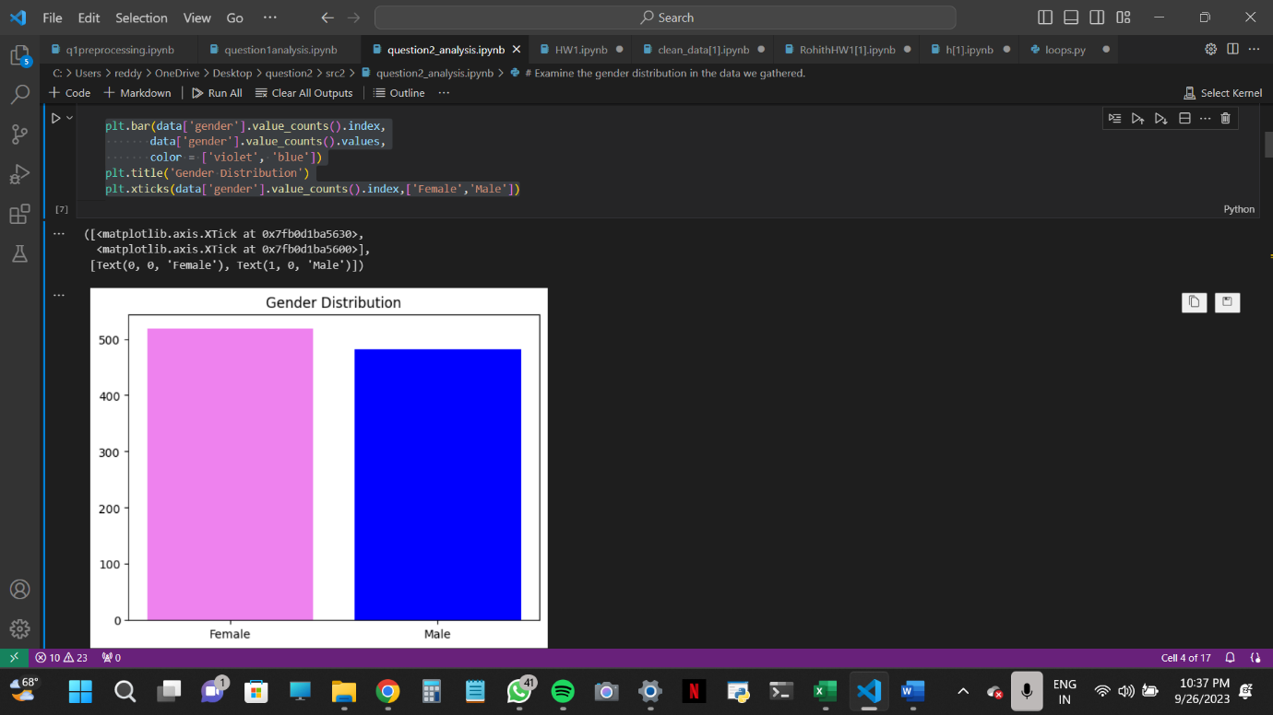

B) This code generates a set of four box graphs that investigate gender inequalities in a variety of areas (math, reading, writing, and total). The 'darkgrid' style is utilized to offer a distinct aesthetic appearance. The charts allow you to see score distributions and possible gender discrepancies.

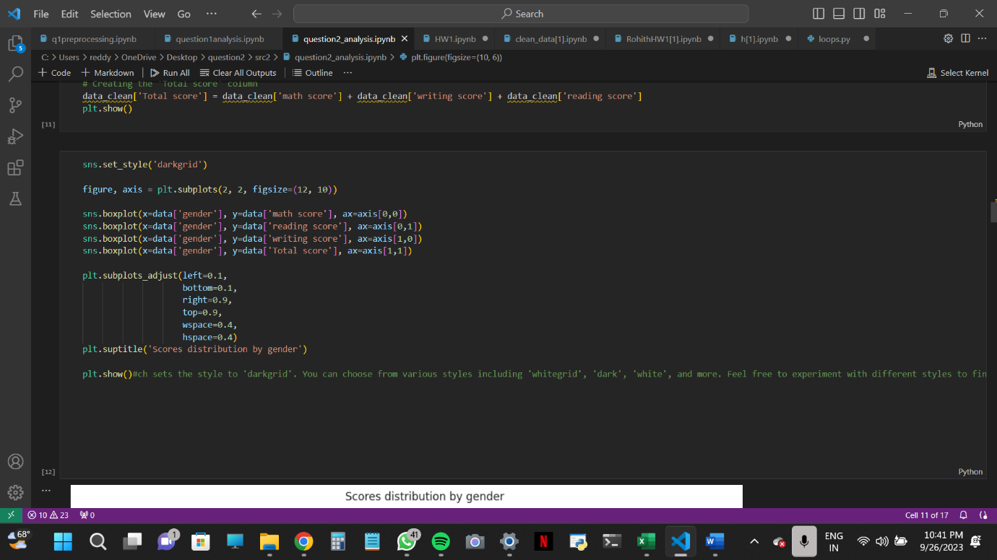

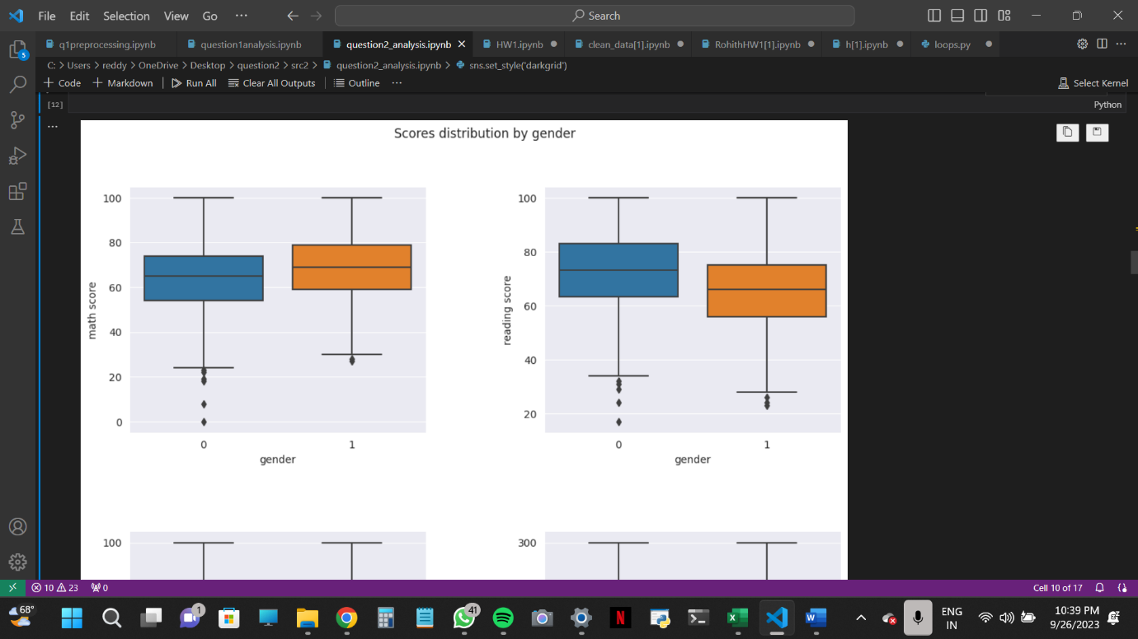

C) This code generates a count plot of the distribution of parental education levels in the dataset. The x-axis shows different levels of parental education, and the y-axis shows the corresponding counts. The chart details the educational backgrounds of the sample's parents. The x-axis labels have been changed to make them more visible.

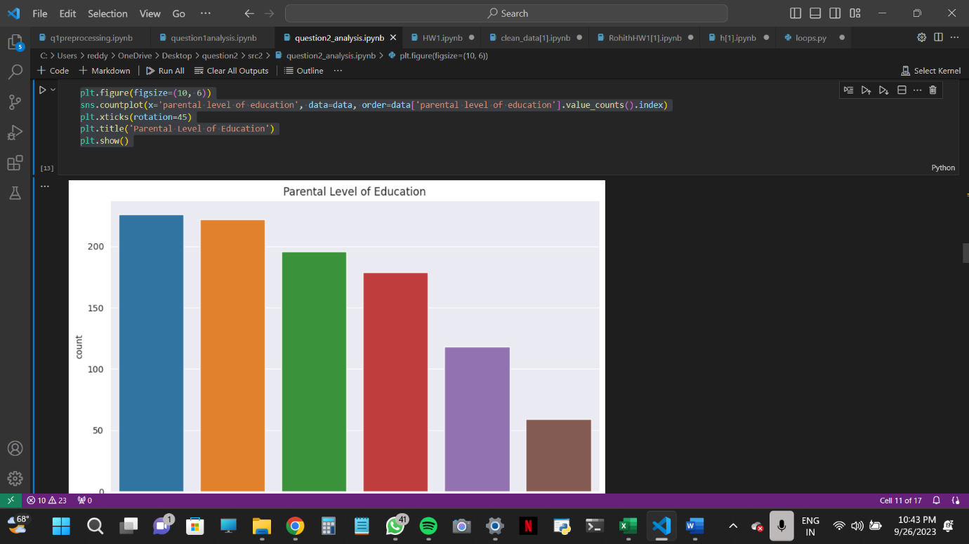

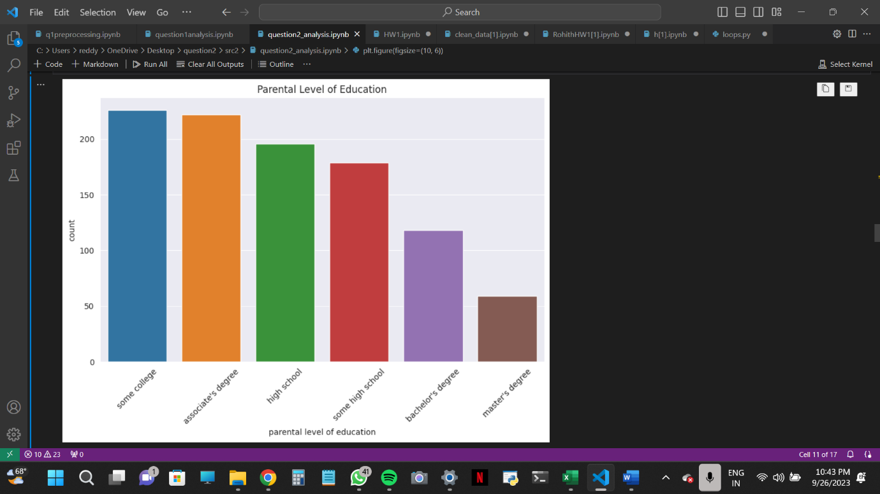

D) This code builds a histogram that displays the frequency distribution of the dataset's total scores. The x-axis, which is divided into 20 bins, depicts the total scores. The frequency of scores falling into each bin is given on the y-axis. The histogram illustrates the overall distribution pattern of total scores.

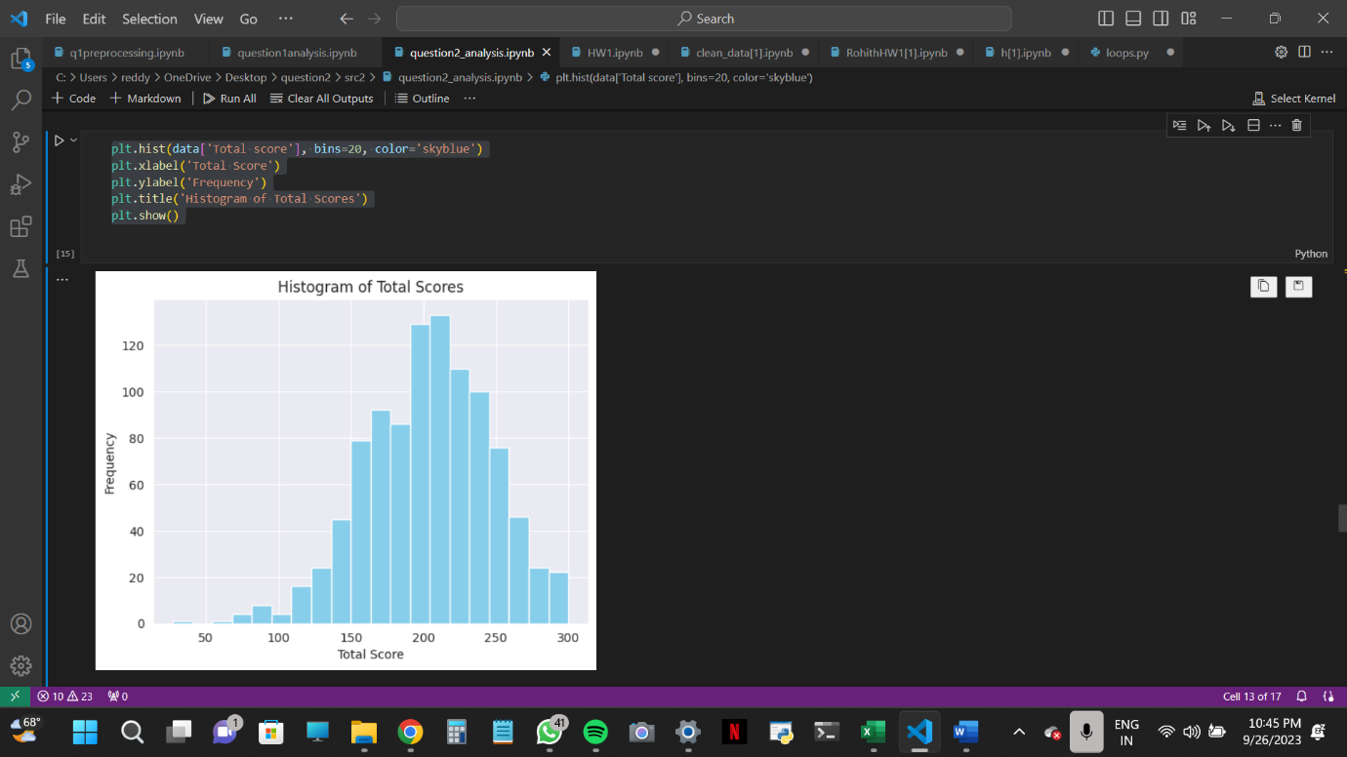

E) This code generates a heatmap that depicts the correlations between the dataset's math, reading, writing, and total scores. The intensity of the color and the number annotations serve as visual signals about the strength and direction of the links. The heatmap aids in the identification of any notable links between the various categories of ratings.

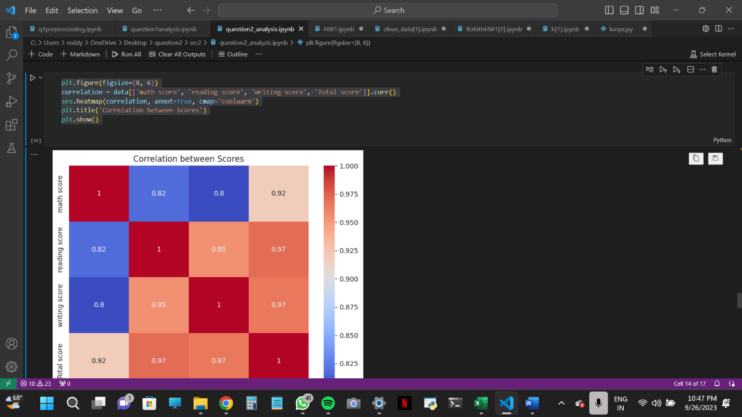

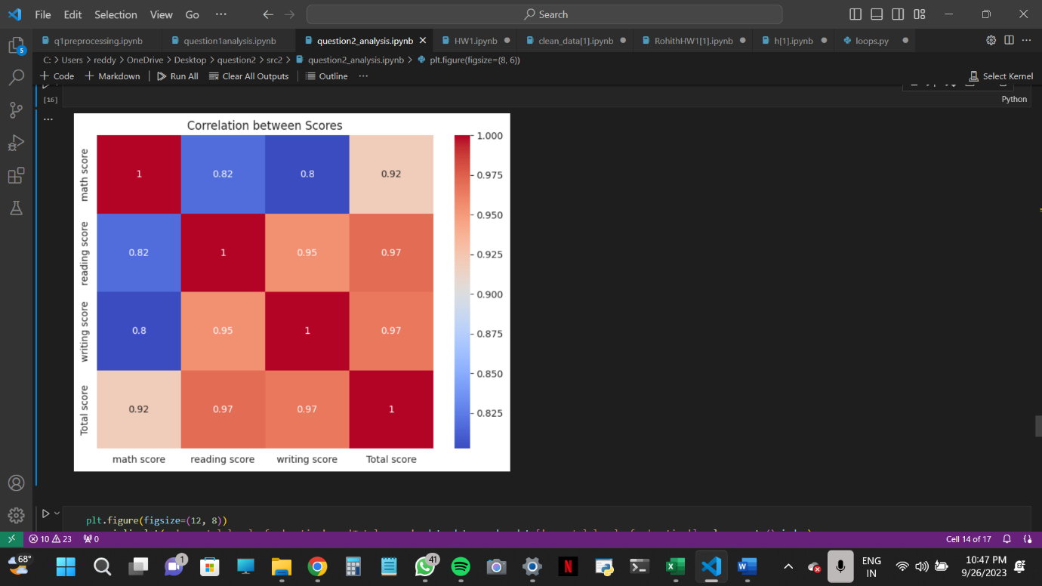

Thank you